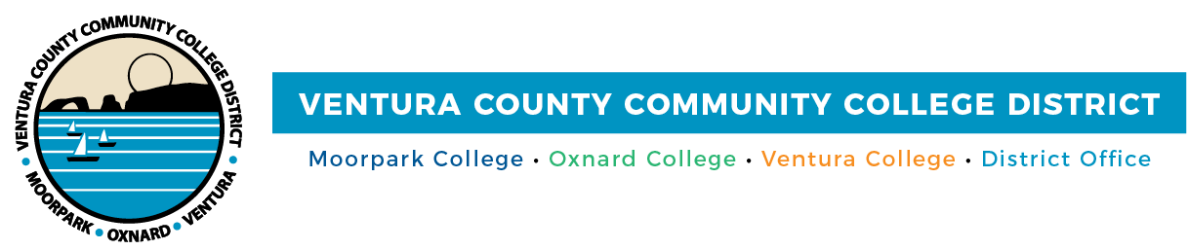

FOR IMMEDIATE RELEASE

VCCCD Receives Statewide CISOA Technology Excellence Team Award
Honor reflects information technology team’s rapid response to remote workplace needs

Camarillo, Calif. (February 11, 2021)—When the COVID-19 pandemic required Ventura County Community College District’s employees to transition to remote work in March, the District’s information technology team faced a challenge. They needed to provide over 500 employees with an immediate, reliable secure process for accessing their core applications and files. A transition process that historically would take six to 10 weeks, the IT team did in 10 days. They accomplished this feat by evaluating, selecting and implementing Amazon AppStream 2.0, a fully managed application and desktop streaming service built on Amazon Web Services.

In recognition of the teams’ seamless execution of the new software and sharing of best practices with other California community colleges, the District received the CISOA Technology Excellence Team Award at the 2021 CISOA Virtual Technology Summit on Feb. 11. CISOA (Chief Information Systems Officers Association) is a nonprofit organization supporting technology leadership in the California Community College System.

“This award reflects the awe-inspiring work of Michael Rose, Dean Adams, Jon Gallagher, Victory Kitamura and Marc Boman,” said Dan Watkins, VCCCD associate vice chancellor, information technology. “The District had never used Amazon AppStream and it seemed something new to the entire California Community College System. I can't emphasize enough the dedication and work ethic of these individuals to ‘build the plane while flying.’”

“This honor speaks to the talent of the District’s Amazon AppStream Implementation Team, which enabled employees to efficiently transition to remote work while meeting the needs of our approximately 31,000 students and faculty and staff at Moorpark, Oxnard and Ventura colleges,” said Chancellor Greg Gillespie.

“The board of trustees is grateful for the tremendous effort of the IT team to facilitate this new system for the health and safety of the District’s employees and to comply with Governor Newsom’s stay-at-home orders. The team not only worked around the clock to provide employees access, they generously shared their knowledge with districts throughout the state,” added Board Chair Joshua Chancer.

About Ventura County Community College District

The Ventura County Community College District is a member of the 116-campus California Community College system and serves approximately 31,000 students annually. The District's three colleges--Moorpark, Oxnard and Ventura--offer programs in general education for degrees and certificates, transfer to four-year colleges and universities, career technical education, and provide opportunities to engage in co-curricular campus activities. For more information, please visit vcccd.edu.

Media Contact:
Patti Blair
Director, Public Affairs and Marketing
Ventura County Community College District
communications@vcccd.edu

